NoSQL; Class 1

## 1/ Introduction

Motivation : Big Data

Volume, Velocity, Variety

-> High scalability, Database server, flexible data model

Focus on **MongoDB** in this course

## 2/ MongoDB

1. Construction

In a relational SQL database, we have:

* On server side: mysqld (mysql server daemon)
* On client side: Workbench, mysql shell (for example)

In MongoDB:

* Client : Mongo, Compass
* Server-side: **mongod**

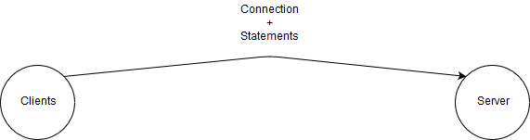

1. Organization

|  |  |
| --- | --- |
| **Relational** | **MongoDB** |
| Database | Database |
| Table | Collection |
| Row | Json document (more flexible) |
| column | field/key |

1. CRUD operations

**CRUD**: **C**reate **R**ead **U**pdate **D**elete

1. Command line examples (to be used on the videos.js database)

db.load(“path avec des / ”)

db.movieDetails.findOne()

db.movieDetails.find({year: 1968}, {title: 1, director:1, _id:0})

db.movieDetails.find({year: {$eq: 1968}}, {title: 1, director:1, _id:0})

db.movieDetails.find({year: {$gte: 1968}, director: "Sergio Leone"}, {title: 1, director:1, _id:0}).count()

db.movieDetails.find({$or: [{year: {$gte: 1968}}, {director: "Sergio Leone"}]}, {title: 1, director:1, _id:0})

db.movieDetails.find({ year: {$gte: 1968, $lte: 2000}}, {title: 1, director:1, year:1, _id:0})

db.movieDetails.find({ director: /^S.*e$/}, {title: 1, director:1, year:1, _id:0})

db.movieDetails.find({ director: /^S.*[azerty]+$/}, {title: 1, director:1, year:1, _id:0})

1. Operators

List of operators in MongoDB:

* $eq - $ne (equal to / not equal to)
* $gt - $gte (greater than / greater than and equal to)
* $lt - $lte (lower than / lower than and equal to)
* $in - $nin (is in / is not in)
* $and
* $size: specifies all documents with two elements in an attribute

Regex (regular expression)

* **^**: identifies beginning of the string
* **$**: identifies end of the string
* **.** : looks for any character specified in parameters (only 1 character at a time)
* **\*** : Specifies that any character appearing before the **\*** appears only once
* **+** : The character is repeated one or more times
* ? : the character appears once or is repeated one time
* [xxxx] : one character in the set

1. gfds